FBL1N- Vendor Line Item Display
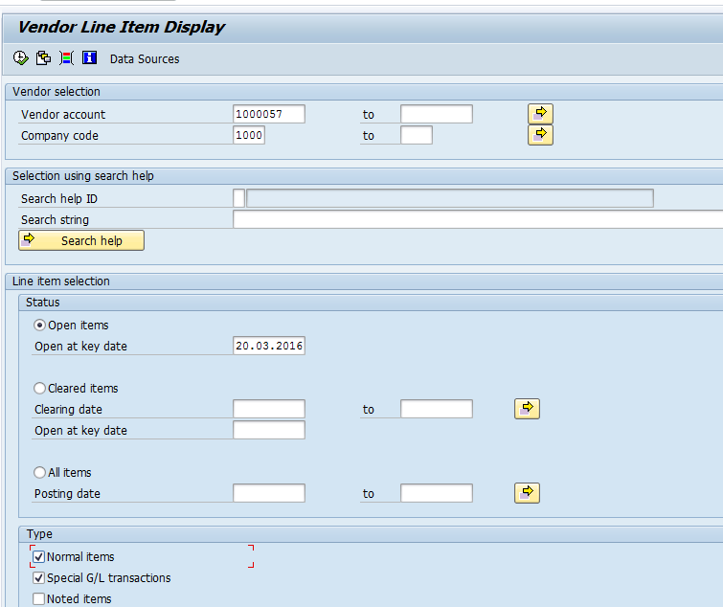
The following are the input criteria for extracting the Vendor line item display
Vendor Selection: Under this section
- Vendor Account: Input the Vendor Number in this field
- Company Code: Input the Company code
Line Item Selection: Under Line item section
- Open Items: Upon selecting this radio button system will displays the Open items information (which is due for payment)
- Cleared Items: Upon selecting this radio button system will display the cleared items information (which are paid)
- All Items: Upon selecting this radio button system will display both Open item and Cleared items information
Type: Under this section
Normal Items: Set the check box where system will display the invoice items(normal items)
Special G/L transactions: Set the check box where system will display the information related to down payment etc.

Vendor Open item Display
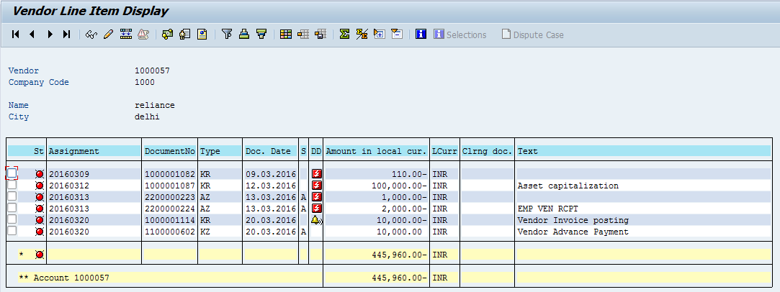
- Vendor Down(Advance) payment status will reflect with Red color
- Vendor Down (Advance) payment will be displayed with “Spl GL Indicator A”

F-44 – Vendor Down(Advance Clearing)

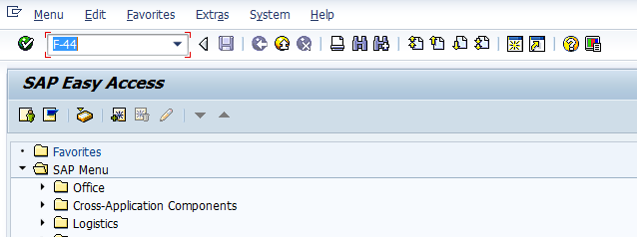
- Input F-44 in Transaction box and press Enter key

Clearing Vendor Header Data
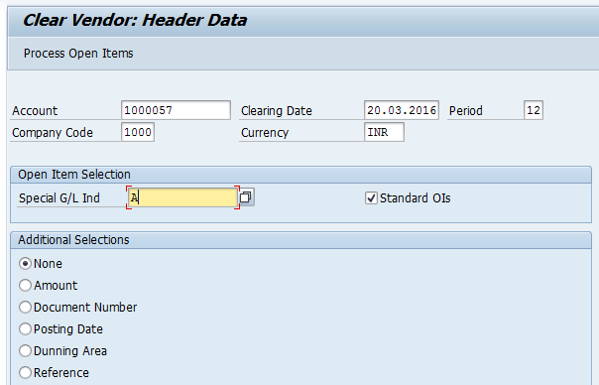
The following are the Input fields under the Vendor Clearing Document data
- Account: Input the Vendor Number in this field
- Company Code: Input the Company code information in this field
- Clearing Date: Input the transaction date in the Clearing date field
- Currency: Input the Currency INR in the Currency field
- Special GL Ind: Input the Special GL Indicator “A” in this field and select “Process Open item” button
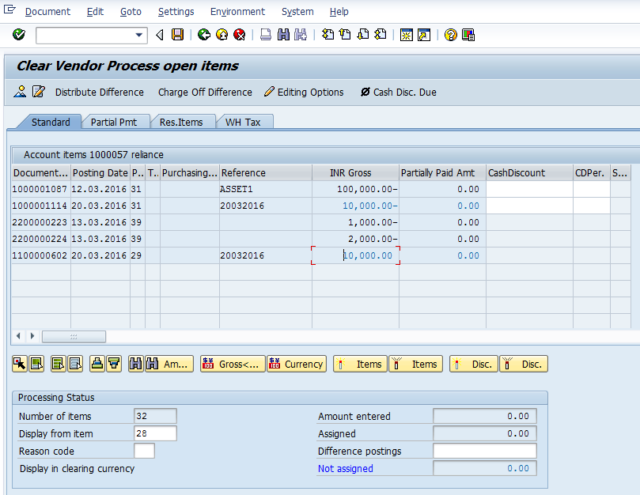
- Select All items Icon and select Deactivate items tab
- Double Click on the line items(Debit and Credit) which will get activated(turns in to Blue colour)
- Select Document option in Menu, choose Simulate option.

Simulation of Transaction before posting:
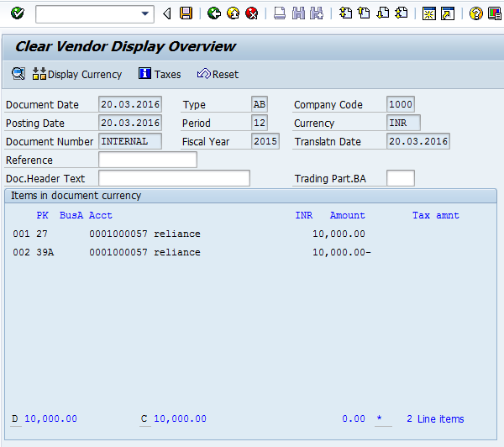
Simulate: Click on Simulate option. System will display the line items (Debit and Credit entry).
- Check the entries, if the entries are correct, click to Post Button
- If the entries are not okay, then go to Main screen and take required action to correct it.

Document Posting
- Document is posted, An information will be populated at the bottom of the screen

Document Display View
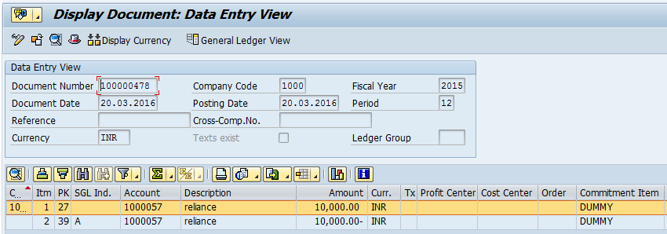
We can view the transaction in two ways:
- Display Document: From Menu bar select Document option it will display the options Change, Display, Post and Save as completed. Choose Display option. Document successfully got posted will get displayed
- Input FB03 in Transaction box and system will take us to Document Display screen. Input the Document number and Press Enter key. Document posted will get displayed.

FBL1N- Vendor Line Item Display
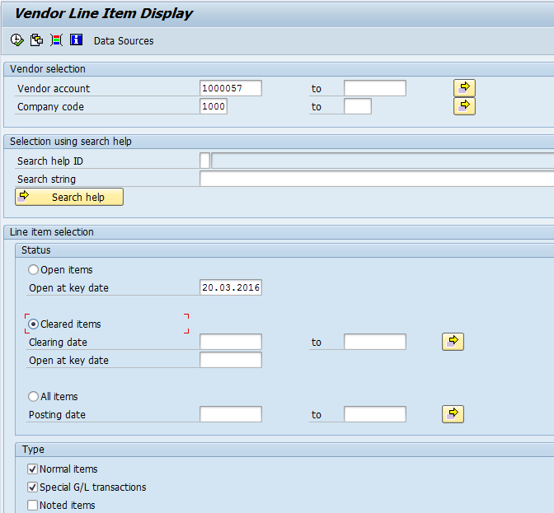
- Select Cleared Items radio button and click on Execute button. System will display the Line items which are cleared and status will be displayed in Green color

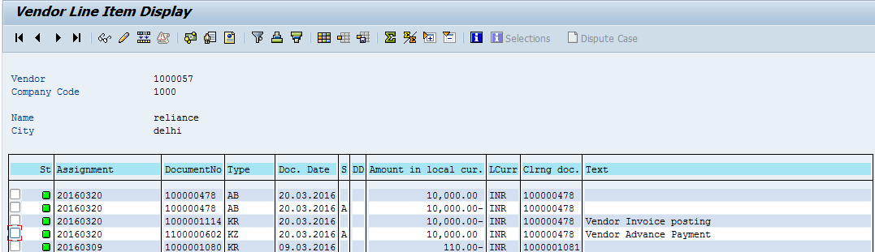
Manual End

